**Addition.java (Practical 1B)**

/*

* To change this license header, choose License Headers in Project Properties.

* To change this template file, choose Tools | Templates

* and open the template in the editor.

*/

/**

*

* @author Nikhil

*/

public class Frame1 extends javax.swing.JFrame {

/**

* Creates new form Frame1

*/

public Frame1() {

initComponents();

}

/**

* This method is called from within the constructor to initialize the form.

* WARNING: Do NOT modify this code. The content of this method is always

* regenerated by the Form Editor.

*/

@SuppressWarnings("unchecked")

// <editor-fold defaultstate="collapsed" desc="Generated Code">

private void initComponents() {

jButton1 = new javax.swing.JButton();

jLabel1 = new javax.swing.JLabel();

jLabel2 = new javax.swing.JLabel();

jLabel3 = new javax.swing.JLabel();

jButton4 = new javax.swing.JButton();

jScrollPane2 = new javax.swing.JScrollPane();

jTextArea2 = new javax.swing.JTextArea();

jTextField1 = new javax.swing.JTextField();

jTextField2 = new javax.swing.JTextField();

jButton1.setText("jButton1");

setDefaultCloseOperation(javax.swing.WindowConstants.EXIT_ON_CLOSE);

jLabel1.setText("Number 1");

jLabel2.setText("Number 2");

jLabel3.setText("answer :");

jButton4.setText("Addition");

jButton4.addActionListener(new java.awt.event.ActionListener() {

public void actionPerformed(java.awt.event.ActionEvent evt) {

jButton4ActionPerformed(evt);

}

});

jTextArea2.setColumns(20);

jTextArea2.setRows(5);

jScrollPane2.setViewportView(jTextArea2);

javax.swing.GroupLayout layout = new javax.swing.GroupLayout(getContentPane());

getContentPane().setLayout(layout);

layout.setHorizontalGroup(

layout.createParallelGroup(javax.swing.GroupLayout.Alignment.LEADING)

.addGroup(layout.createSequentialGroup()

.addGroup(layout.createParallelGroup(javax.swing.GroupLayout.Alignment.LEADING)

.addGroup(layout.createSequentialGroup()

.addGap(91, 91, 91)

.addGroup(layout.createParallelGroup(javax.swing.GroupLayout.Alignment.LEADING)

.addComponent(jLabel2)

.addComponent(jLabel1))

.addGap(162, 162, 162)

.addGroup(layout.createParallelGroup(javax.swing.GroupLayout.Alignment.LEADING)

.addGroup(layout.createSequentialGroup()

.addGap(20, 20, 20)

.addComponent(jScrollPane2, javax.swing.GroupLayout.PREFERRED_SIZE, 142, javax.swing.GroupLayout.PREFERRED_SIZE))

.addGroup(layout.createParallelGroup(javax.swing.GroupLayout.Alignment.TRAILING, false)

.addComponent(jTextField1, javax.swing.GroupLayout.Alignment.LEADING, javax.swing.GroupLayout.DEFAULT_SIZE, 70, Short.MAX_VALUE)

.addComponent(jTextField2, javax.swing.GroupLayout.Alignment.LEADING))))

.addGroup(layout.createSequentialGroup()

.addGap(202, 202, 202)

.addGroup(layout.createParallelGroup(javax.swing.GroupLayout.Alignment.LEADING)

.addComponent(jButton4)

.addComponent(jLabel3, javax.swing.GroupLayout.PREFERRED_SIZE, 85, javax.swing.GroupLayout.PREFERRED_SIZE))))

.addContainerGap(65, Short.MAX_VALUE))

);

layout.setVerticalGroup(

layout.createParallelGroup(javax.swing.GroupLayout.Alignment.LEADING)

.addGroup(layout.createSequentialGroup()

.addGap(28, 28, 28)

.addGroup(layout.createParallelGroup(javax.swing.GroupLayout.Alignment.LEADING)

.addComponent(jScrollPane2, javax.swing.GroupLayout.Alignment.TRAILING, javax.swing.GroupLayout.PREFERRED_SIZE, 0, javax.swing.GroupLayout.PREFERRED_SIZE)

.addGroup(layout.createParallelGroup(javax.swing.GroupLayout.Alignment.BASELINE)

.addComponent(jLabel1)

.addComponent(jTextField1, javax.swing.GroupLayout.PREFERRED_SIZE, javax.swing.GroupLayout.DEFAULT_SIZE, javax.swing.GroupLayout.PREFERRED_SIZE)))

.addGap(33, 33, 33)

.addGroup(layout.createParallelGroup(javax.swing.GroupLayout.Alignment.BASELINE)

.addComponent(jLabel2)

.addComponent(jTextField2, javax.swing.GroupLayout.PREFERRED_SIZE, javax.swing.GroupLayout.DEFAULT_SIZE, javax.swing.GroupLayout.PREFERRED_SIZE))

.addPreferredGap(javax.swing.LayoutStyle.ComponentPlacement.RELATED, 123, Short.MAX_VALUE)

.addComponent(jButton4)

.addPreferredGap(javax.swing.LayoutStyle.ComponentPlacement.RELATED)

.addComponent(jLabel3, javax.swing.GroupLayout.PREFERRED_SIZE, 24, javax.swing.GroupLayout.PREFERRED_SIZE)

.addContainerGap())

);

pack();

}// </editor-fold>

private void jButton4ActionPerformed(java.awt.event.ActionEvent evt) {

// TODO add your handling code here:

int n1=Integer.parseInt(jTextField1.getText());

int n2=Integer.parseInt(jTextField2.getText());

int c= n1+n2;

jLabel3.setText("answer: "+c);

//JOptionPane.showMessageDialog(null,"Answer: "+c);

}

/**

* @param args the command line arguments

*/

public static void main(String args[]) {

/* Set the Nimbus look and feel */

//<editor-fold defaultstate="collapsed" desc=" Look and feel setting code (optional) ">

/* If Nimbus (introduced in Java SE 6) is not available, stay with the default look and feel.

* For details see http://download.oracle.com/javase/tutorial/uiswing/lookandfeel/plaf.html

*/

try {

for (javax.swing.UIManager.LookAndFeelInfo info : javax.swing.UIManager.getInstalledLookAndFeels()) {

if ("Nimbus".equals(info.getName())) {

javax.swing.UIManager.setLookAndFeel(info.getClassName());

break;

}

}

} catch (ClassNotFoundException ex) {

java.util.logging.Logger.getLogger(Frame1.class.getName()).log(java.util.logging.Level.SEVERE, null, ex);

} catch (InstantiationException ex) {

java.util.logging.Logger.getLogger(Frame1.class.getName()).log(java.util.logging.Level.SEVERE, null, ex);

} catch (IllegalAccessException ex) {

java.util.logging.Logger.getLogger(Frame1.class.getName()).log(java.util.logging.Level.SEVERE, null, ex);

} catch (javax.swing.UnsupportedLookAndFeelException ex) {

java.util.logging.Logger.getLogger(Frame1.class.getName()).log(java.util.logging.Level.SEVERE, null, ex);

}

//</editor-fold>

/* Create and display the form */

java.awt.EventQueue.invokeLater(new Runnable() {

public void run() {

new Frame1().setVisible(true);

}

});

}

// Variables declaration - do not modify

private javax.swing.JButton jButton1;

private javax.swing.JButton jButton4;

private javax.swing.JLabel jLabel1;

private javax.swing.JLabel jLabel2;

private javax.swing.JLabel jLabel3;

private javax.swing.JScrollPane jScrollPane2;

private javax.swing.JTextArea jTextArea2;

private javax.swing.JTextField jTextField1;

private javax.swing.JTextField jTextField2;

// End of variables declaration

}

**Output:**

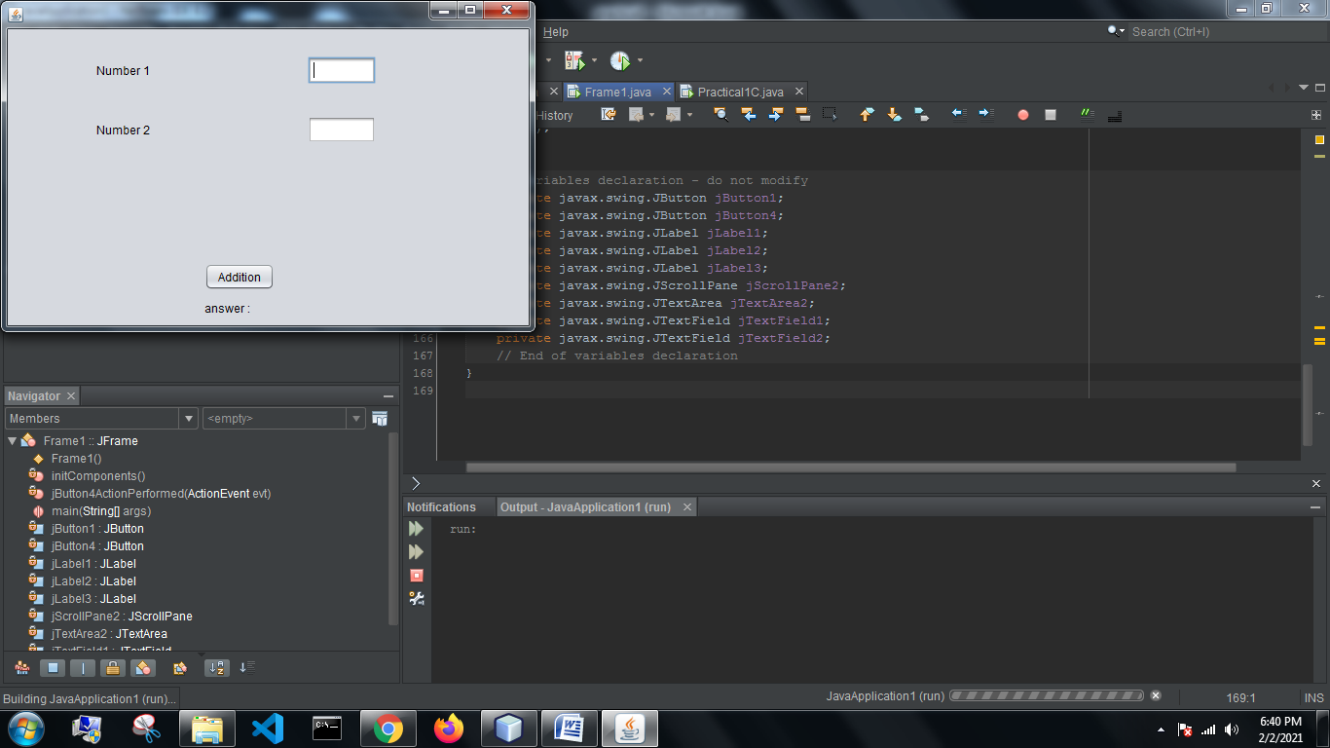

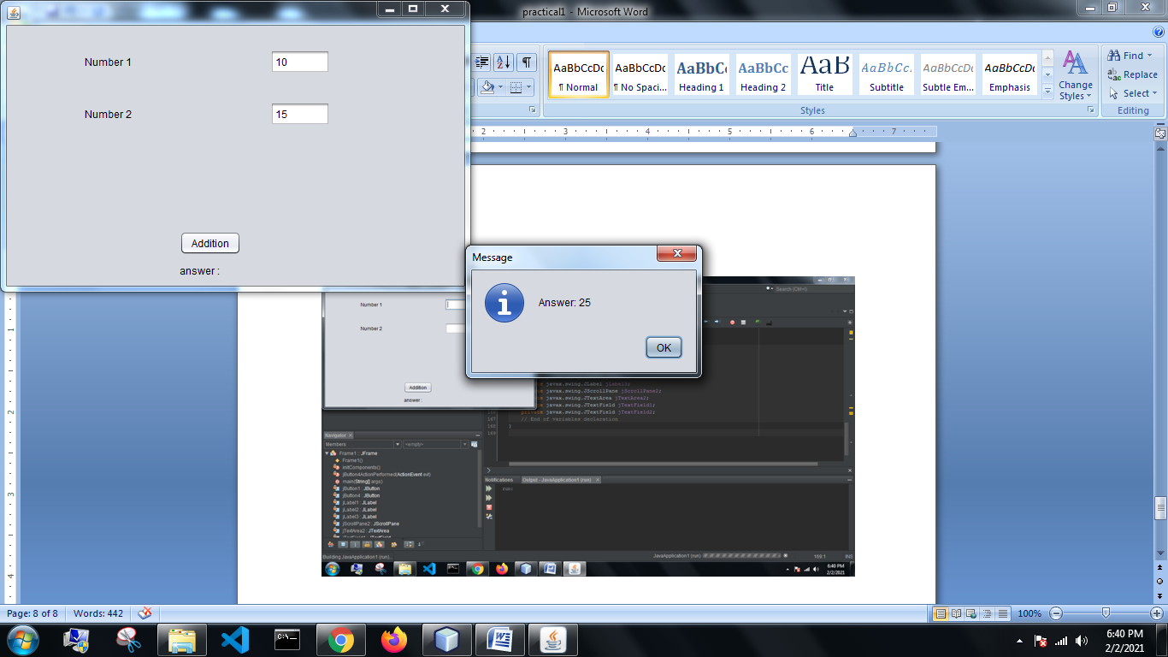

**Calculator.java (Practical 1C)**

import javax.swing.JOptionPane;

/*

* To change this license header, choose License Headers in Project Properties.

* To change this template file, choose Tools | Templates

* and open the template in the editor.

*/

/**

*

* @author Nikhil

*/

public class Practical1C extends javax.swing.JFrame {

/**

* Creates new form Practical1C

*/

public Practical1C() {

initComponents();

}

/**

* This method is called from within the constructor to initialize the form.

* WARNING: Do NOT modify this code. The content of this method is always

* regenerated by the Form Editor.

*/

@SuppressWarnings("unchecked")

// <editor-fold defaultstate="collapsed" desc="Generated Code">

private void initComponents() {

jLabel1 = new javax.swing.JLabel();

jLabel2 = new javax.swing.JLabel();

jTextField1 = new javax.swing.JTextField();

jTextField2 = new javax.swing.JTextField();

jComboBox1 = new javax.swing.JComboBox<>();

jLabel3 = new javax.swing.JLabel();

jLabel4 = new javax.swing.JLabel();

jButton1 = new javax.swing.JButton();

setDefaultCloseOperation(javax.swing.WindowConstants.EXIT_ON_CLOSE);

jLabel1.setText("Number 1");

jLabel2.setText("Number 2");

jTextField2.addActionListener(new java.awt.event.ActionListener() {

public void actionPerformed(java.awt.event.ActionEvent evt) {

jTextField2ActionPerformed(evt);

}

});

jComboBox1.setModel(new javax.swing.DefaultComboBoxModel<>(new String[] { "+", "-", "X", "/", "%" }));

jComboBox1.addActionListener(new java.awt.event.ActionListener() {

public void actionPerformed(java.awt.event.ActionEvent evt) {

jComboBox1ActionPerformed(evt);

}

});

jLabel3.setText("Operator");

jLabel4.setText("answer :");

jButton1.setText("calculate");

jButton1.addActionListener(new java.awt.event.ActionListener() {

public void actionPerformed(java.awt.event.ActionEvent evt) {

jButton1ActionPerformed(evt);

}

});

javax.swing.GroupLayout layout = new javax.swing.GroupLayout(getContentPane());

getContentPane().setLayout(layout);

layout.setHorizontalGroup(

layout.createParallelGroup(javax.swing.GroupLayout.Alignment.LEADING)

.addGroup(javax.swing.GroupLayout.Alignment.TRAILING, layout.createSequentialGroup()

.addGap(94, 94, 94)

.addGroup(layout.createParallelGroup(javax.swing.GroupLayout.Alignment.TRAILING)

.addGroup(layout.createSequentialGroup()

.addComponent(jLabel3)

.addPreferredGap(javax.swing.LayoutStyle.ComponentPlacement.RELATED, 86, Short.MAX_VALUE)

.addComponent(jComboBox1, javax.swing.GroupLayout.PREFERRED_SIZE, 65, javax.swing.GroupLayout.PREFERRED_SIZE))

.addGroup(layout.createSequentialGroup()

.addGroup(layout.createParallelGroup(javax.swing.GroupLayout.Alignment.LEADING)

.addComponent(jLabel1)

.addComponent(jLabel2))

.addPreferredGap(javax.swing.LayoutStyle.ComponentPlacement.RELATED, javax.swing.GroupLayout.DEFAULT_SIZE, Short.MAX_VALUE)

.addGroup(layout.createParallelGroup(javax.swing.GroupLayout.Alignment.LEADING, false)

.addComponent(jTextField1, javax.swing.GroupLayout.DEFAULT_SIZE, 100, Short.MAX_VALUE)

.addComponent(jTextField2))))

.addGap(87, 104, Short.MAX_VALUE))

.addGroup(layout.createSequentialGroup()

.addGroup(layout.createParallelGroup(javax.swing.GroupLayout.Alignment.LEADING)

.addGroup(layout.createSequentialGroup()

.addGap(174, 174, 174)

.addComponent(jLabel4))

.addGroup(layout.createSequentialGroup()

.addGap(159, 159, 159)

.addComponent(jButton1)))

.addContainerGap(javax.swing.GroupLayout.DEFAULT_SIZE, Short.MAX_VALUE))

);

layout.setVerticalGroup(

layout.createParallelGroup(javax.swing.GroupLayout.Alignment.LEADING)

.addGroup(layout.createSequentialGroup()

.addGap(45, 45, 45)

.addGroup(layout.createParallelGroup(javax.swing.GroupLayout.Alignment.BASELINE)

.addComponent(jLabel1)

.addComponent(jTextField1, javax.swing.GroupLayout.PREFERRED_SIZE, javax.swing.GroupLayout.DEFAULT_SIZE, javax.swing.GroupLayout.PREFERRED_SIZE))

.addGap(19, 19, 19)

.addGroup(layout.createParallelGroup(javax.swing.GroupLayout.Alignment.BASELINE)

.addComponent(jLabel2)

.addComponent(jTextField2, javax.swing.GroupLayout.PREFERRED_SIZE, javax.swing.GroupLayout.DEFAULT_SIZE, javax.swing.GroupLayout.PREFERRED_SIZE))

.addGap(23, 23, 23)

.addGroup(layout.createParallelGroup(javax.swing.GroupLayout.Alignment.BASELINE)

.addComponent(jLabel3)

.addComponent(jComboBox1, javax.swing.GroupLayout.PREFERRED_SIZE, javax.swing.GroupLayout.DEFAULT_SIZE, javax.swing.GroupLayout.PREFERRED_SIZE))

.addPreferredGap(javax.swing.LayoutStyle.ComponentPlacement.RELATED, 69, Short.MAX_VALUE)

.addComponent(jButton1)

.addPreferredGap(javax.swing.LayoutStyle.ComponentPlacement.RELATED)

.addComponent(jLabel4)

.addGap(16, 16, 16))

);

pack();

}// </editor-fold>

private void jComboBox1ActionPerformed(java.awt.event.ActionEvent evt) {

// TODO add your handling code here:

}

private void jTextField2ActionPerformed(java.awt.event.ActionEvent evt) {

// TODO add your handling code here:

}

private void jButton1ActionPerformed(java.awt.event.ActionEvent evt) {

// TODO add your handling code here:

String o=jComboBox1.getSelectedItem().toString();

int n1=Integer.parseInt(jTextField1.getText());

int n2=Integer.parseInt(jTextField2.getText());

int c = 0;

if(o.equals("+")){c=n1+n2;}

if(o.equals("-")){c=n1-n2;}

if(o.equals("X")){c=n1*n2;}

if(o.equals("/")){c=n1/n2;}

if(o.equals("%")){c=n1%n2;}

JOptionPane.showMessageDialog(null,"answer="+c );

}

/**

* @param args the command line arguments

*/

public static void main(String args[]) {

/* Set the Nimbus look and feel */

//<editor-fold defaultstate="collapsed" desc=" Look and feel setting code (optional) ">

/* If Nimbus (introduced in Java SE 6) is not available, stay with the default look and feel.

* For details see http://download.oracle.com/javase/tutorial/uiswing/lookandfeel/plaf.html

*/

try {

for (javax.swing.UIManager.LookAndFeelInfo info : javax.swing.UIManager.getInstalledLookAndFeels()) {

if ("Nimbus".equals(info.getName())) {

javax.swing.UIManager.setLookAndFeel(info.getClassName());

break;

}

}

} catch (ClassNotFoundException ex) {

java.util.logging.Logger.getLogger(Practical1C.class.getName()).log(java.util.logging.Level.SEVERE, null, ex);

} catch (InstantiationException ex) {

java.util.logging.Logger.getLogger(Practical1C.class.getName()).log(java.util.logging.Level.SEVERE, null, ex);

} catch (IllegalAccessException ex) {

java.util.logging.Logger.getLogger(Practical1C.class.getName()).log(java.util.logging.Level.SEVERE, null, ex);

} catch (javax.swing.UnsupportedLookAndFeelException ex) {

java.util.logging.Logger.getLogger(Practical1C.class.getName()).log(java.util.logging.Level.SEVERE, null, ex);

}

//</editor-fold>

/* Create and display the form */

java.awt.EventQueue.invokeLater(new Runnable() {

public void run() {

new Practical1C().setVisible(true);

}

});

}

// Variables declaration - do not modify

private javax.swing.JButton jButton1;

private javax.swing.JComboBox<String> jComboBox1;

private javax.swing.JLabel jLabel1;

private javax.swing.JLabel jLabel2;

private javax.swing.JLabel jLabel3;

private javax.swing.JLabel jLabel4;

private javax.swing.JTextField jTextField1;

private javax.swing.JTextField jTextField2;

// End of variables declaration

}

**Output:**

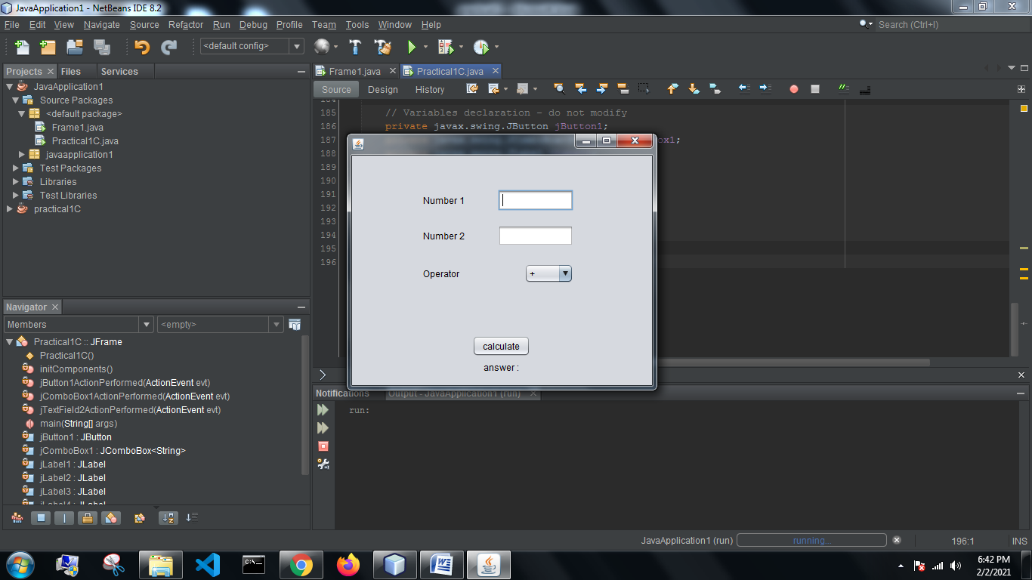

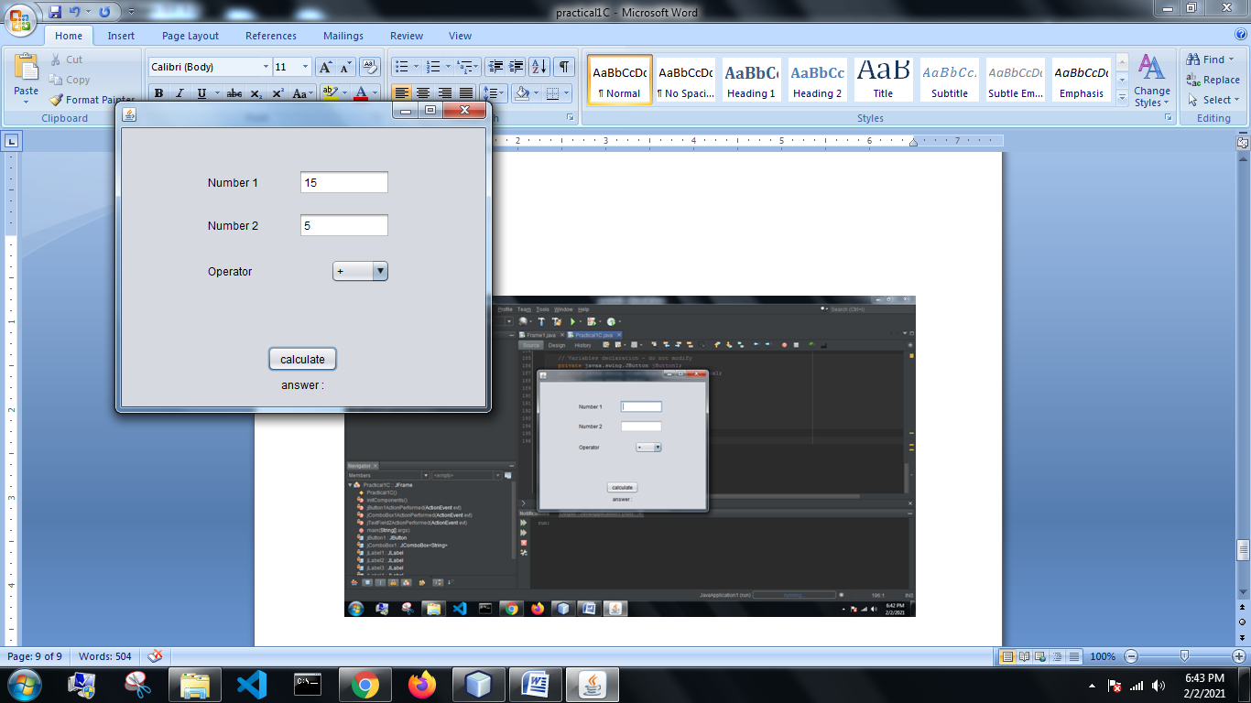

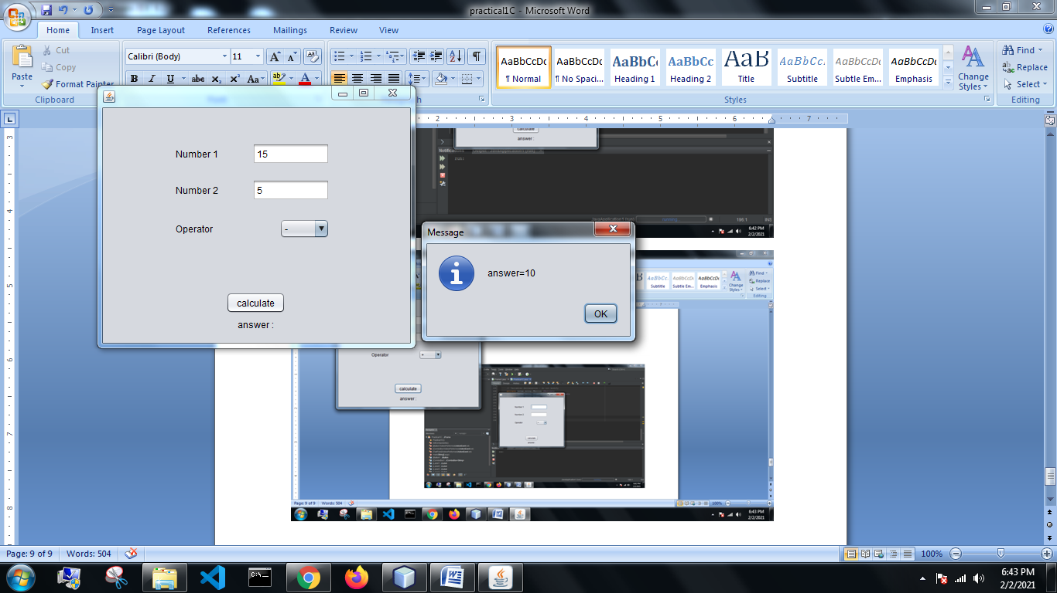

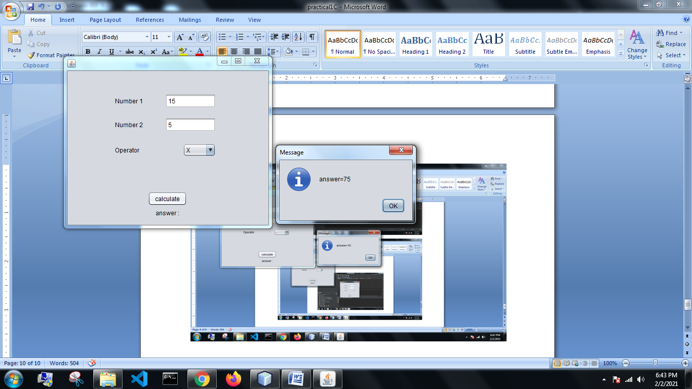

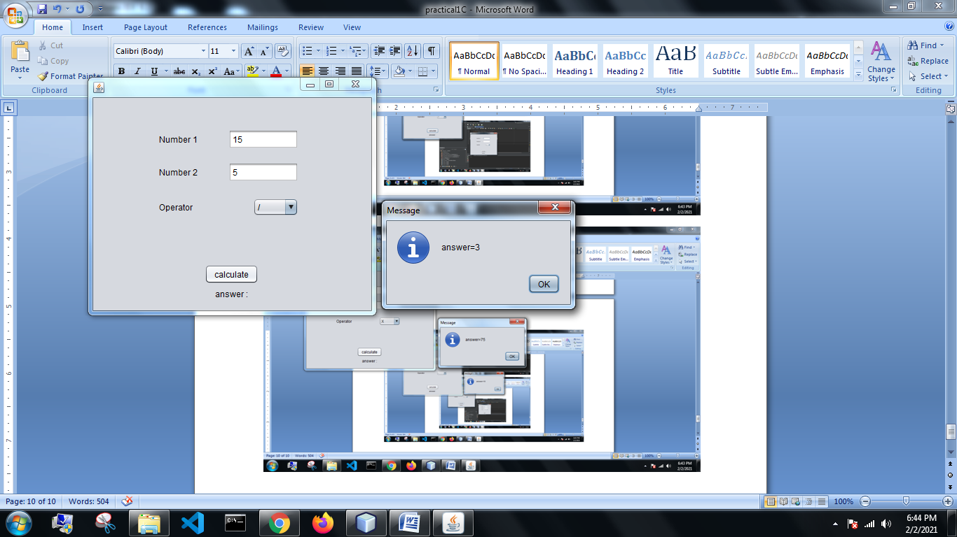

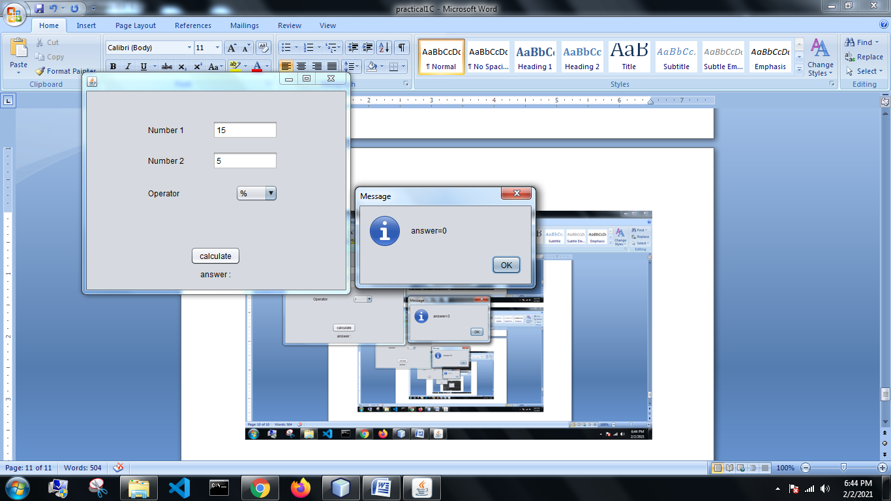

**Login.java (Practical 1D)**

import javax.swing.JOptionPane;

/*

* To change this license header, choose License Headers in Project Properties.

* To change this template file, choose Tools | Templates

* and open the template in the editor.

*/

/**

*

* @author Nikhil

*/

public class Practical1D extends javax.swing.JFrame {

/**

* Creates new form Practical1D

*/

public Practical1D() {

initComponents();

}

/**

* This method is called from within the constructor to initialize the form.

* WARNING: Do NOT modify this code. The content of this method is always

* regenerated by the Form Editor.

*/

@SuppressWarnings("unchecked")

// <editor-fold defaultstate="collapsed" desc="Generated Code">

private void initComponents() {

jLabel1 = new javax.swing.JLabel();

jLabel2 = new javax.swing.JLabel();

jTextField1 = new javax.swing.JTextField();

jTextField2 = new javax.swing.JTextField();

jButton1 = new javax.swing.JButton();

setDefaultCloseOperation(javax.swing.WindowConstants.EXIT_ON_CLOSE);

jLabel1.setText("Name");

jLabel2.setText("Pass");

jButton1.setText("Submit");

jButton1.addActionListener(new java.awt.event.ActionListener() {

public void actionPerformed(java.awt.event.ActionEvent evt) {

jButton1ActionPerformed(evt);

}

});

javax.swing.GroupLayout layout = new javax.swing.GroupLayout(getContentPane());

getContentPane().setLayout(layout);

layout.setHorizontalGroup(

layout.createParallelGroup(javax.swing.GroupLayout.Alignment.LEADING)

.addGroup(layout.createSequentialGroup()

.addGroup(layout.createParallelGroup(javax.swing.GroupLayout.Alignment.LEADING)

.addGroup(layout.createSequentialGroup()

.addGap(113, 113, 113)

.addGroup(layout.createParallelGroup(javax.swing.GroupLayout.Alignment.LEADING)

.addComponent(jLabel1)

.addComponent(jLabel2))

.addGap(61, 61, 61)

.addGroup(layout.createParallelGroup(javax.swing.GroupLayout.Alignment.LEADING, false)

.addComponent(jTextField2, javax.swing.GroupLayout.DEFAULT_SIZE, 70, Short.MAX_VALUE)

.addComponent(jTextField1)))

.addGroup(layout.createSequentialGroup()

.addGap(149, 149, 149)

.addComponent(jButton1)))

.addContainerGap(123, Short.MAX_VALUE))

);

layout.setVerticalGroup(

layout.createParallelGroup(javax.swing.GroupLayout.Alignment.LEADING)

.addGroup(layout.createSequentialGroup()

.addGap(69, 69, 69)

.addGroup(layout.createParallelGroup(javax.swing.GroupLayout.Alignment.BASELINE)

.addComponent(jLabel1)

.addComponent(jTextField1, javax.swing.GroupLayout.PREFERRED_SIZE, javax.swing.GroupLayout.DEFAULT_SIZE, javax.swing.GroupLayout.PREFERRED_SIZE))

.addGap(18, 18, 18)

.addGroup(layout.createParallelGroup(javax.swing.GroupLayout.Alignment.BASELINE)

.addComponent(jLabel2)

.addComponent(jTextField2, javax.swing.GroupLayout.PREFERRED_SIZE, javax.swing.GroupLayout.DEFAULT_SIZE, javax.swing.GroupLayout.PREFERRED_SIZE))

.addGap(18, 18, 18)

.addComponent(jButton1)

.addContainerGap(115, Short.MAX_VALUE))

);

pack();

}// </editor-fold>

private void jButton1ActionPerformed(java.awt.event.ActionEvent evt) {

// TODO add your handling code here:

String a=jTextField1.getText();

String b=jTextField2.getText();

if(a.equals("nikhil") && b.equals("password") ){

JOptionPane.showMessageDialog(null,"welcome "+a+" login sucessfull");

}

else{

JOptionPane.showMessageDialog(null," wrong credentials");

}

}

/**

* @param args the command line arguments

*/

public static void main(String args[]) {

/* Set the Nimbus look and feel */

//<editor-fold defaultstate="collapsed" desc=" Look and feel setting code (optional) ">

/* If Nimbus (introduced in Java SE 6) is not available, stay with the default look and feel.

* For details see http://download.oracle.com/javase/tutorial/uiswing/lookandfeel/plaf.html

*/

try {

for (javax.swing.UIManager.LookAndFeelInfo info : javax.swing.UIManager.getInstalledLookAndFeels()) {

if ("Nimbus".equals(info.getName())) {

javax.swing.UIManager.setLookAndFeel(info.getClassName());

break;

}

}

} catch (ClassNotFoundException ex) {

java.util.logging.Logger.getLogger(Practical1D.class.getName()).log(java.util.logging.Level.SEVERE, null, ex);

} catch (InstantiationException ex) {

java.util.logging.Logger.getLogger(Practical1D.class.getName()).log(java.util.logging.Level.SEVERE, null, ex);

} catch (IllegalAccessException ex) {

java.util.logging.Logger.getLogger(Practical1D.class.getName()).log(java.util.logging.Level.SEVERE, null, ex);

} catch (javax.swing.UnsupportedLookAndFeelException ex) {

java.util.logging.Logger.getLogger(Practical1D.class.getName()).log(java.util.logging.Level.SEVERE, null, ex);

}

//</editor-fold>

/* Create and display the form */

java.awt.EventQueue.invokeLater(new Runnable() {

public void run() {

new Practical1D().setVisible(true);

}

});

}

// Variables declaration - do not modify

private javax.swing.JButton jButton1;

private javax.swing.JLabel jLabel1;

private javax.swing.JLabel jLabel2;

private javax.swing.JTextField jTextField1;

private javax.swing.JTextField jTextField2;

// End of variables declaration

}

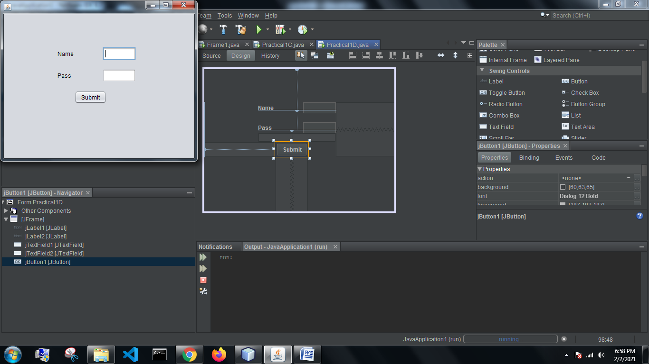

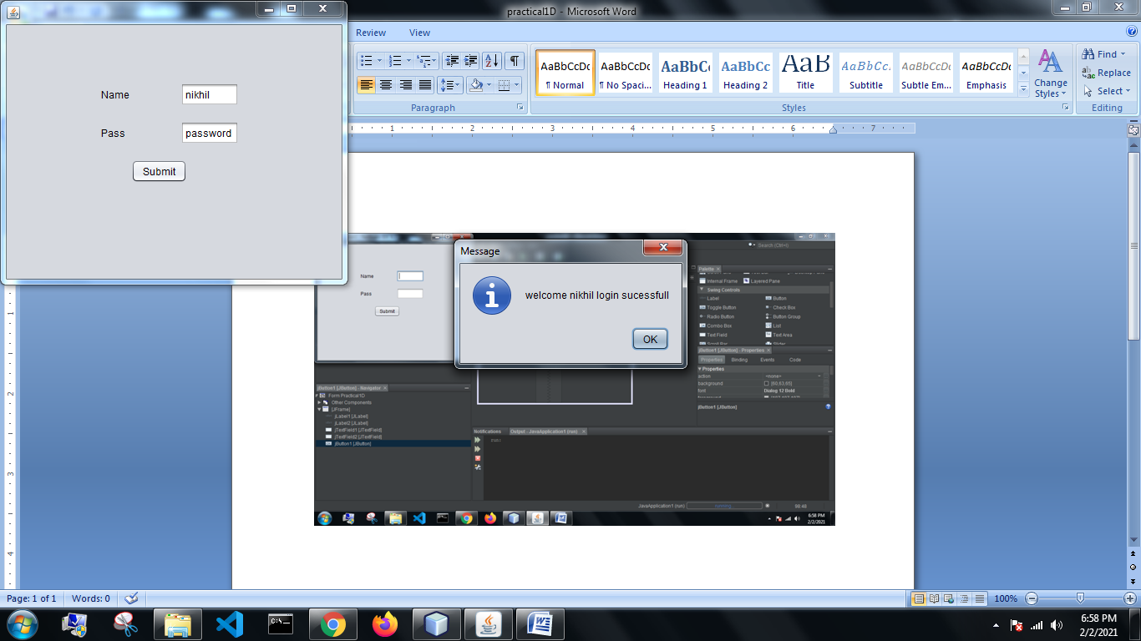

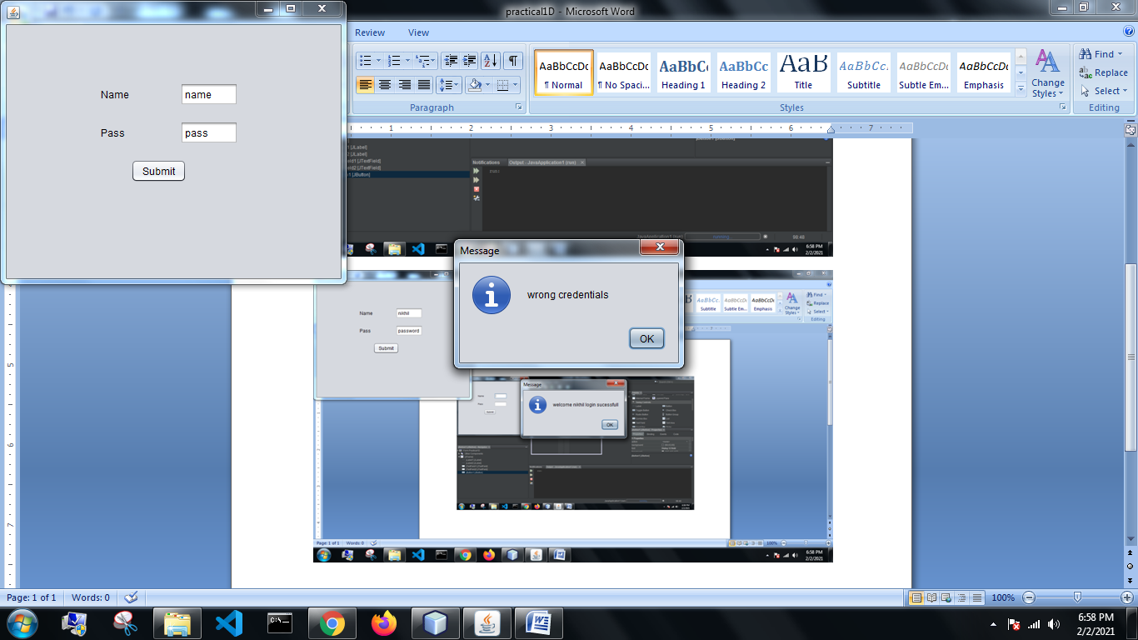

**Registration.java (Practical 1E)**

import java.util.Arrays;

import javax.swing.JOptionPane;

/*

* To change this license header, choose License Headers in Project Properties.

* To change this template file, choose Tools | Templates

* and open the template in the editor.

*/

/**

*

* @author Nikhil

*/

public class Practical1E extends javax.swing.JFrame {

/**

* Creates new form Practical1E

*/

public Practical1E() {

initComponents();

}

/**

* This method is called from within the constructor to initialize the form.

* WARNING: Do NOT modify this code. The content of this method is always

* regenerated by the Form Editor.

*/

@SuppressWarnings("unchecked")

// <editor-fold defaultstate="collapsed" desc="Generated Code">

private void initComponents() {

buttonGroup1 = new javax.swing.ButtonGroup();

jLabel1 = new javax.swing.JLabel();

jTextField1 = new javax.swing.JTextField();

jLabel2 = new javax.swing.JLabel();

jTextField2 = new javax.swing.JTextField();

jLabel3 = new javax.swing.JLabel();

jTextField3 = new javax.swing.JTextField();

jLabel4 = new javax.swing.JLabel();

jRadioButton1 = new javax.swing.JRadioButton();

jRadioButton2 = new javax.swing.JRadioButton();

jRadioButton3 = new javax.swing.JRadioButton();

jLabel5 = new javax.swing.JLabel();

jComboBox1 = new javax.swing.JComboBox<>();

jLabel6 = new javax.swing.JLabel();

jCheckBox1 = new javax.swing.JCheckBox();

jCheckBox2 = new javax.swing.JCheckBox();

jCheckBox3 = new javax.swing.JCheckBox();

jLabel7 = new javax.swing.JLabel();

jScrollPane1 = new javax.swing.JScrollPane();

jTextArea1 = new javax.swing.JTextArea();

jButton1 = new javax.swing.JButton();

jLabel8 = new javax.swing.JLabel();

jPasswordField1 = new javax.swing.JPasswordField();

setDefaultCloseOperation(javax.swing.WindowConstants.EXIT_ON_CLOSE);

jLabel1.setText("Name");

jLabel2.setText("Email");

jLabel3.setText("Age");

jLabel4.setText("Gender");

buttonGroup1.add(jRadioButton1);

jRadioButton1.setText("Male");

jRadioButton1.addActionListener(new java.awt.event.ActionListener() {

public void actionPerformed(java.awt.event.ActionEvent evt) {

jRadioButton1ActionPerformed(evt);

}

});

buttonGroup1.add(jRadioButton2);

jRadioButton2.setText("Female");

buttonGroup1.add(jRadioButton3);

jRadioButton3.setText("Other");

jRadioButton3.addActionListener(new java.awt.event.ActionListener() {

public void actionPerformed(java.awt.event.ActionEvent evt) {

jRadioButton3ActionPerformed(evt);

}

});

jLabel5.setText("Last Exam Passed");

jComboBox1.setModel(new javax.swing.DefaultComboBoxModel<>(new String[] { "SSC", "HSC", "Graduate", "Post Graduate", "PhD" }));

jLabel6.setText("Hobbies");

jCheckBox1.setText("Chess");

jCheckBox2.setText("Swimming");

jCheckBox3.setText("Singing");

jCheckBox3.addActionListener(new java.awt.event.ActionListener() {

public void actionPerformed(java.awt.event.ActionEvent evt) {

jCheckBox3ActionPerformed(evt);

}

});

jLabel7.setText("Address");

jTextArea1.setColumns(20);

jTextArea1.setRows(5);

jScrollPane1.setViewportView(jTextArea1);

jButton1.setText("Submit");

jButton1.addActionListener(new java.awt.event.ActionListener() {

public void actionPerformed(java.awt.event.ActionEvent evt) {

jButton1ActionPerformed(evt);

}

});

jLabel8.setText("Password");

javax.swing.GroupLayout layout = new javax.swing.GroupLayout(getContentPane());

getContentPane().setLayout(layout);

layout.setHorizontalGroup(

layout.createParallelGroup(javax.swing.GroupLayout.Alignment.LEADING)

.addGroup(layout.createSequentialGroup()

.addGroup(layout.createParallelGroup(javax.swing.GroupLayout.Alignment.LEADING)

.addGroup(layout.createSequentialGroup()

.addGap(23, 23, 23)

.addGroup(layout.createParallelGroup(javax.swing.GroupLayout.Alignment.LEADING)

.addComponent(jLabel1)

.addComponent(jLabel2)

.addComponent(jLabel3)

.addComponent(jLabel4)

.addComponent(jLabel8))

.addPreferredGap(javax.swing.LayoutStyle.ComponentPlacement.RELATED, 210, Short.MAX_VALUE)

.addComponent(jRadioButton1)

.addGap(18, 18, 18)

.addComponent(jRadioButton2)

.addGap(18, 18, 18)

.addComponent(jRadioButton3))

.addGroup(layout.createSequentialGroup()

.addGap(27, 27, 27)

.addGroup(layout.createParallelGroup(javax.swing.GroupLayout.Alignment.LEADING)

.addComponent(jLabel5)

.addComponent(jLabel6)

.addComponent(jLabel7))

.addPreferredGap(javax.swing.LayoutStyle.ComponentPlacement.RELATED, 91, Short.MAX_VALUE)

.addGroup(layout.createParallelGroup(javax.swing.GroupLayout.Alignment.LEADING, false)

.addGroup(layout.createSequentialGroup()

.addComponent(jCheckBox1)

.addGap(33, 33, 33)

.addComponent(jCheckBox2)

.addPreferredGap(javax.swing.LayoutStyle.ComponentPlacement.RELATED, 44, Short.MAX_VALUE)

.addComponent(jCheckBox3))

.addGroup(layout.createSequentialGroup()

.addGroup(layout.createParallelGroup(javax.swing.GroupLayout.Alignment.LEADING, false)

.addComponent(jTextField1, javax.swing.GroupLayout.Alignment.TRAILING, javax.swing.GroupLayout.DEFAULT_SIZE, 156, Short.MAX_VALUE)

.addComponent(jTextField2, javax.swing.GroupLayout.Alignment.TRAILING)

.addComponent(jTextField3, javax.swing.GroupLayout.Alignment.TRAILING)

.addComponent(jPasswordField1, javax.swing.GroupLayout.Alignment.TRAILING))

.addGap(76, 76, 76))

.addGroup(javax.swing.GroupLayout.Alignment.TRAILING, layout.createSequentialGroup()

.addComponent(jComboBox1, javax.swing.GroupLayout.PREFERRED_SIZE, javax.swing.GroupLayout.DEFAULT_SIZE, javax.swing.GroupLayout.PREFERRED_SIZE)

.addGap(112, 112, 112))

.addComponent(jScrollPane1))))

.addGap(64, 64, 64))

.addGroup(layout.createSequentialGroup()

.addGap(98, 98, 98)

.addComponent(jButton1)

.addContainerGap(javax.swing.GroupLayout.DEFAULT_SIZE, Short.MAX_VALUE))

);

layout.setVerticalGroup(

layout.createParallelGroup(javax.swing.GroupLayout.Alignment.LEADING)

.addGroup(layout.createSequentialGroup()

.addContainerGap()

.addGroup(layout.createParallelGroup(javax.swing.GroupLayout.Alignment.LEADING)

.addGroup(layout.createSequentialGroup()

.addComponent(jTextField1, javax.swing.GroupLayout.PREFERRED_SIZE, javax.swing.GroupLayout.DEFAULT_SIZE, javax.swing.GroupLayout.PREFERRED_SIZE)

.addGap(18, 18, 18)

.addGroup(layout.createParallelGroup(javax.swing.GroupLayout.Alignment.BASELINE)

.addComponent(jTextField2, javax.swing.GroupLayout.PREFERRED_SIZE, javax.swing.GroupLayout.DEFAULT_SIZE, javax.swing.GroupLayout.PREFERRED_SIZE)

.addComponent(jLabel2))

.addGap(18, 18, 18)

.addGroup(layout.createParallelGroup(javax.swing.GroupLayout.Alignment.LEADING)

.addComponent(jLabel3)

.addComponent(jTextField3, javax.swing.GroupLayout.PREFERRED_SIZE, javax.swing.GroupLayout.DEFAULT_SIZE, javax.swing.GroupLayout.PREFERRED_SIZE)))

.addComponent(jLabel1))

.addGap(18, 18, 18)

.addGroup(layout.createParallelGroup(javax.swing.GroupLayout.Alignment.BASELINE)

.addComponent(jLabel8)

.addComponent(jPasswordField1, javax.swing.GroupLayout.PREFERRED_SIZE, javax.swing.GroupLayout.DEFAULT_SIZE, javax.swing.GroupLayout.PREFERRED_SIZE))

.addGap(19, 19, 19)

.addGroup(layout.createParallelGroup(javax.swing.GroupLayout.Alignment.LEADING, false)

.addGroup(layout.createParallelGroup(javax.swing.GroupLayout.Alignment.BASELINE)

.addComponent(jRadioButton2)

.addComponent(jRadioButton3))

.addGroup(layout.createParallelGroup(javax.swing.GroupLayout.Alignment.BASELINE)

.addComponent(jRadioButton1)

.addComponent(jLabel4)))

.addPreferredGap(javax.swing.LayoutStyle.ComponentPlacement.UNRELATED)

.addGroup(layout.createParallelGroup(javax.swing.GroupLayout.Alignment.BASELINE)

.addComponent(jLabel5)

.addComponent(jComboBox1, javax.swing.GroupLayout.PREFERRED_SIZE, javax.swing.GroupLayout.DEFAULT_SIZE, javax.swing.GroupLayout.PREFERRED_SIZE))

.addGroup(layout.createParallelGroup(javax.swing.GroupLayout.Alignment.LEADING)

.addGroup(layout.createSequentialGroup()

.addGap(42, 42, 42)

.addComponent(jLabel7))

.addGroup(layout.createSequentialGroup()

.addGroup(layout.createParallelGroup(javax.swing.GroupLayout.Alignment.BASELINE)

.addComponent(jCheckBox1)

.addComponent(jCheckBox2)

.addComponent(jLabel6)

.addComponent(jCheckBox3))

.addGap(18, 18, 18)

.addComponent(jScrollPane1, javax.swing.GroupLayout.PREFERRED_SIZE, 45, javax.swing.GroupLayout.PREFERRED_SIZE)))

.addPreferredGap(javax.swing.LayoutStyle.ComponentPlacement.RELATED, javax.swing.GroupLayout.DEFAULT_SIZE, Short.MAX_VALUE)

.addComponent(jButton1)

.addContainerGap())

);

pack();

}// </editor-fold>

private void jRadioButton3ActionPerformed(java.awt.event.ActionEvent evt) {

// TODO add your handling code here:

}

private void jRadioButton1ActionPerformed(java.awt.event.ActionEvent evt) {

// TODO add your handling code here:

}

private void jCheckBox3ActionPerformed(java.awt.event.ActionEvent evt) {

// TODO add your handling code here:

}

private void jButton1ActionPerformed(java.awt.event.ActionEvent evt) {

// TODO add your handling code here:

String firstname=jTextField1.getText();

String email=jTextField2.getText();

String age=jTextField3.getText();

char password[];

password = jPasswordField1.getPassword();

jRadioButton1.setActionCommand("male");

jRadioButton2.setActionCommand("female");

jRadioButton3.setActionCommand("other");

String gender=buttonGroup1.getSelection().getActionCommand();

String address=jTextArea1.getText();

String check1=jCheckBox1.getText();

String check2=jCheckBox2.getText();

String check3=jCheckBox3.getText();

String component=new String();

if(jCheckBox1.isSelected()){

component=check1+",";

}

if(jCheckBox2.isSelected()){

component+=check2+",";

}

if(jCheckBox3.isSelected()){

component+=check3+",";

}

String detail;

detail="firstname:"+firstname+"\nage:"+age+"\nemail:"+email+"\npassword:"+Arrays.toString(password)+"\ngender:"+gender+

"\nAddress:"+address+"\nHobbies:"+component;

JOptionPane.showMessageDialog(this,detail);

}

/**

* @param args the command line arguments

*/

public static void main(String args[]) {

/* Set the Nimbus look and feel */

//<editor-fold defaultstate="collapsed" desc=" Look and feel setting code (optional) ">

/* If Nimbus (introduced in Java SE 6) is not available, stay with the default look and feel.

* For details see http://download.oracle.com/javase/tutorial/uiswing/lookandfeel/plaf.html

*/

try {

for (javax.swing.UIManager.LookAndFeelInfo info : javax.swing.UIManager.getInstalledLookAndFeels()) {

if ("Nimbus".equals(info.getName())) {

javax.swing.UIManager.setLookAndFeel(info.getClassName());

break;

}

}

} catch (ClassNotFoundException ex) {

java.util.logging.Logger.getLogger(Practical1E.class.getName()).log(java.util.logging.Level.SEVERE, null, ex);

} catch (InstantiationException ex) {

java.util.logging.Logger.getLogger(Practical1E.class.getName()).log(java.util.logging.Level.SEVERE, null, ex);

} catch (IllegalAccessException ex) {

java.util.logging.Logger.getLogger(Practical1E.class.getName()).log(java.util.logging.Level.SEVERE, null, ex);

} catch (javax.swing.UnsupportedLookAndFeelException ex) {

java.util.logging.Logger.getLogger(Practical1E.class.getName()).log(java.util.logging.Level.SEVERE, null, ex);

}

//</editor-fold>

/* Create and display the form */

java.awt.EventQueue.invokeLater(new Runnable() {

public void run() {

new Practical1E().setVisible(true);

}

});

}

// Variables declaration - do not modify

private javax.swing.ButtonGroup buttonGroup1;

private javax.swing.JButton jButton1;

private javax.swing.JCheckBox jCheckBox1;

private javax.swing.JCheckBox jCheckBox2;

private javax.swing.JCheckBox jCheckBox3;

private javax.swing.JComboBox<String> jComboBox1;

private javax.swing.JLabel jLabel1;

private javax.swing.JLabel jLabel2;

private javax.swing.JLabel jLabel3;

private javax.swing.JLabel jLabel4;

private javax.swing.JLabel jLabel5;

private javax.swing.JLabel jLabel6;

private javax.swing.JLabel jLabel7;

private javax.swing.JLabel jLabel8;

private javax.swing.JPasswordField jPasswordField1;

private javax.swing.JRadioButton jRadioButton1;

private javax.swing.JRadioButton jRadioButton2;

private javax.swing.JRadioButton jRadioButton3;

private javax.swing.JScrollPane jScrollPane1;

private javax.swing.JTextArea jTextArea1;

private javax.swing.JTextField jTextField1;

private javax.swing.JTextField jTextField2;

private javax.swing.JTextField jTextField3;

// End of variables declaration

}

